File conversion procedures;
Steps;
- Place the test1.VLOG and vlim-datalog.exe on the same(any) folder;
- Open a command prompt and pointing to the folder;
- Type “vlim-datalog.exe –title –types 1,2 vlim-datalog_906035205_2014-12-19.vlog testfinal.csv”;

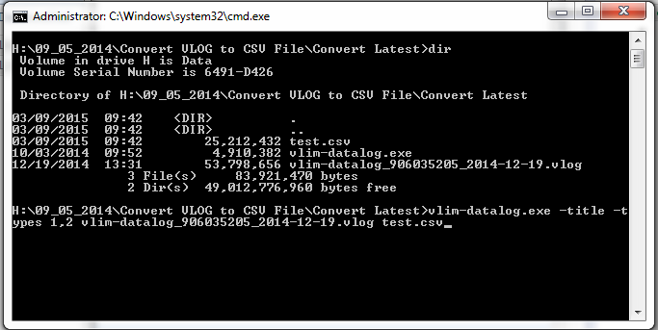
- Check the folder testfinal.csv is generated.
